**CHAPTER: 1 PROJECT STUDY**

**1.1 Introduction**

SMART HEALTH ADVISOR is an open source, online, single window system for almost all health-related issues, facts and information. Its main focus is on rural India, where the lack of knowledge and awareness about health creates a big problem at national as well as global level. Any user can check their BMI, target Heart rate and Body Fat Percentage, etc. Any registered user can book appointment with registered doctors/clinic/hospitals and avoid rush to make conversation with doctor. Registered users can also send their reports to concern doctor and talk to them about their health status during treatment and can also take second advice.

The project basically focuses on development of a website for various health care services. Here, the aim to create an environment in which individuals can check their health status. It will be helpful to eliminate the time lagging and cost to get a best treatment. This also provides the facility to get appointment from a specialist doctor of any decease/ health problem and users can discuss problem and get best solution for their problem. Users can find a good hospital by searching options. The website can also suggest some medicines for the common health deceases.

**1.2 Website Feature**

* The project “Smart Health Advisor” is basically developed to provide an environment for individual to checks their health status and get the solution if they have some health problems.
* It provides facility to fix an appointment with the doctor to get perfect solution. Depends on, if doctor has time to meet him/her.
* The users can also search for medicines according their health-related problems and they can search for specialist doctors and hospitals.
* In this there are some free services which are based on calculators for calculating various health parameters for example BMI (body mass index), Body Fat, Total Energy Expenditure (TEE) and Heart Beat Rate (HBR) etc.
* If user’s BMI is not normal (in between 17<BMI<26), they can get diet for change their BMI status from overweight (BMI>25) and underweight (BMI<18) to normal.
* In this website the users can create their profile to proper use of this web.
* User can give feedback to the doctors, on basic of their working status.

If users want to show their health report to doctor, they can send it in any format while they are making appointment with the doctor.

**1.3 Software Used**

**FRONTEND**

* HTML5
* CSS3

**BACKEND**

* PHP (Version5.6)
* MySQL
* JavaScript

**OTHERS**

* Apache (XAMPP Version 5.6) server
* Sublime editor /Notepad+ +

**1.4 Project Analysis**

Requirements analysis encompasses those tasks that go into determining the needs or conditions to meet for a new or alternate project or product. Requirement analysis is critical to the success or failure of a system project. It consists all types of activities and various kind of charts during a project. It mainly consists of the following points:

* Activity list
* Gantt chart
* PERT chart

**1.4.1 List of Activities**

The activity list is essentially an itemized documentation of all of the schedule activities that are part of a particular project.

Activity List:

|  |  |  |  |  |
| --- | --- | --- | --- | --- |
| **S. NO.** | **ACTIVITY NAME** | **ACTIVITY** | **DURATION(DAYS)** | **PREDECESSOR** |
| 1. | **A** | Group selection | 1 |  |
| 2. | **B** | Project selection and study of project and literature review | 3 |  |
| 3. | **C** | Decision of work flow process and work distribution project designing | 1 | B |
| 4. | **D** | Study of WEBPAGE designing using HTML and CSS | 4 | B |
| 5. | **E** | Use of APACHE server, connectivity with webpage | 2 | D |
| 6. | **F** | Database designing | 3 | B |
| 7. | **G** | Implementation of webpage | 4 | D,E |
| 8. | **H** | Integration of work done | 1 | E,F,G |
| 9. | **I** | Testing and final review | 3 | H |
| 10. | **J** | Report and PPT and Presentation | 4 | I |

Table: 1

Activity List

**1.4.2 GANTT Chart**

Gantt chart is a graphical illustration of a schedule that helps to plan, coordinate and track specific tasks (activity) in project.

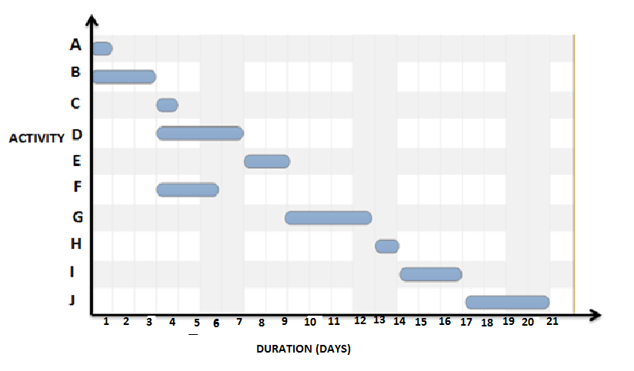

Fig. 1

GANTT CHART

**1.4.3 PERT Chart**

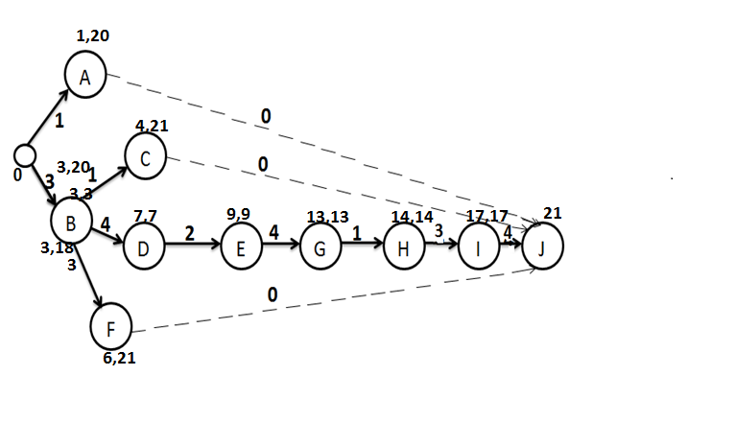Project Evaluation and Review Technique or PERT chart is a project management tool that provides a graphical representation of project timeline.

Fig. 2

PERT CHART

**1.5 Process Model**

A Process Model tells us about how the data is processed and how the data flows from one table to another to gather the required information. This model consists of the Functional Decomposition Diagram and Data Flow Diagram.

* + 1. **Functional Decomposition Diagram**

A decomposition diagram shows a top-down functional decomposition of a system and exposes the system's structure. The objective of the Functional Decomposition is to break down a system step by step, beginning with the main function of a system and continuing with the interim levels down to the level of elementary functions. The diagram is the starting point for more detailed process diagrams, such as data flow diagrams (DFD). Figure 3 shows the Functional Decomposition Diagram for this project.

Home Page

Calculators

Service

Register/Login

Search Medicines

User

Search Locations

Doctor

View/Update Profile

Logout

View Appointments

View Feedback

View /Reply Message

Give/View Feedback

Send Message

Get Appointment

THR

BMI

Body Fat

Enter Weight (In Kg) Enter Height (In Cm)

Enter Age, Height, Weight and Gender

Enter Age and Reserve Heart Rate

Other Services

Calculate

IF BMI

Perfect Health

Normal

Not Normal

Overweight

Underweight

Get Diet/ Doctor Advice

Fig. 3

FDD OF THE PROECT

**CHAPTER: 2 DATABASE DESIGNS**

Database designing is the most important part of any website development project. The database is used to store all the necessary information. And is also useful for checking the validation of input data. The database used for this website consist 7 tables, which are described below.

**2.1 TABLES**

**Table: 1 DOCTOR**

This table will contain all the information of registered doctor given at the time of registration, which can be further edited by EDIT option in their profile page. Attribute “did” is the primary key for this table which is auto incremented field and allotted at the time of registration. Attribute “day” and “time” is the weekdays and timing of appointment provided by doctor.

|  |  |  |  |
| --- | --- | --- | --- |
| **S. NO.** | **NAME** | **TYPE** | **DESCRIPTION** |
| 1. | did | int(11) | auto _increment ,primary key |
| 2. | dname | varchar(255) | Not Null |
| 3. | email | varchar(255) | Not Null |
| 4. | password | varchar(255) | Not Null |
| 5. | locality | varchar(255) |  |
| 6. | city | varchar(255) |  |
| 7. | dmobile | varchar(255) |  |
| 8. | category | varchar(255) | Specialization, Not Null |
| 9. | day | varchar(255) |  |
| 10. | time | varchar(255) |  |
| 11. | Image_location | varchar(100) | Location of profile picture |

Table: 2

Doctor Table

**Table: 2 USERS**

This table will contain all the information of registered members (users) given at the time of registration, which can be further edited by EDIT option in their profile page. Attribute “id” is the primary key for this table which is auto incremented field and allotted at the time of registration by system.

|  |  |  |  |
| --- | --- | --- | --- |
| **S. NO.** | **NAME** | **TYPE** | **DESCRIPTION** |
| 1. | Id | int(11) | Auto increment ,primary key |
| 2. | username | varchar(255) | Name of the user, Not Null |
| 3. | email | varchar(255) | Not Null |
| 4. | phone_no | varchar(11) |  |
| 5. | Age | int(3) |  |
| 6. | Dob | varchar(255) |  |
| 7. | country | varchar(255) |  |
| 8. | City | varchar(255) |  |
| 9. | password | varchar(255) | Not Null |
| 10. | imagelocation | varchar(100) |  |
| 11. | details | Varchar(1000) |  |

Table: 3

Users Table

**Table: 3 DISEASE**

Disease table is used for storing information of medicines for different disease category. For each category at most five medicines can be stored. Each category have a unique “mid” which is auto incremented. Attribute “mid” is the disease id.

|  |  |  |  |
| --- | --- | --- | --- |
| **S. NO.** | **NAME** | **TYPE** | **DESCRIPTION** |
| 1. | mid | int(11) | auto_increment, primary key |
| 2. | name | varchar(255) | Not Null |
| 3. | med1 | varchar(255) |  |
| 4. | med2 | varchar(255) |  |
| 5. | med3 | varchar(255) |  |
| 6. | med4 | varchar(255) |  |
| 7. | med5 | varchar(255) |  |

Table: 4

Disease Table

**Table: 4 BOOKING HISTORY**

Booking History table store all the information related to appointment booking. Attribute “aid” is the appointment id, “did” is the ID of doctor, “uname” is patient name, “category” is the speciation category of doctor, “filename”, “path” and “name” attributes are related to file which is uploaded by user at booking appointment.

|  |  |  |  |
| --- | --- | --- | --- |
| **S. NO.** | **NAME** | **TYPE** | **DESCRIPTION** |
| 1. | aid | int(11) | auto_increment, primary key |
| 2. | did | int(11) |  |
| 3. | uname | varchar(255) |  |
| 4. | date | varchar(255) | Booking date |
| 5. | time | varchar(255) | Booking time |
| 6. | category | varchar(255) |  |
| 7. | filename | varchar(500) |  |
| 8. | name | varchar(500) |  |
| 9. | Path | varchar(500) |  |

Table: 5

Booking History Table

**Table: 5 FEEDBACK**

This table stores all the information related to feedback given by registered users. Attribute “fid” is the feedback id, “name” is the name of user, “dname” is the name of doctor. Attribute “likes” is for view feedback page where user can like a doctor.

|  |  |  |  |
| --- | --- | --- | --- |
| **S. No.** | **Attributes** | **Data Type** | **Description** |
| 1. | name | varchar(100) |  |
| 2. | dname | varchar(100) |  |
| 3. | did | int(11) | Doctor ID |
| 4. | comments | varchar(1000) | Review about doctor |
| 5. | rating | int(10) | Out of 5 |
| 6. | fid | int(50) | auto_increment, primary key |
| 7. | likes | int(50) |  |

Table: 6

Feedback Table

**Table: 6 CHAT**

This CHAT table is useful in message sending. This table is used to store all the related messages and their information. Attribute “msg_id” is the auto incremented field here. Attribute “date” stores the date and time of message sending.

|  |  |  |  |
| --- | --- | --- | --- |
| S.No | Attributes | Data Type | Desciption |
|  | msg_id | Int(11) | Auto_incremented, primery key |
|  | Uname | Varchar(255) | Sender’s name |
|  | did | Int(11) | Receiver’s ID |
|  | Msg | Varchar(1000) | Message contained |
|  | Date | Timestamp(6) | Date & time of message passing |

Table: 7

Chat Table

**Table: 7 REPLY**

This table stores all the information related to reply by doctor to patient. Attribute “id” is the reply id.

|  |  |  |  |
| --- | --- | --- | --- |
| S.No | Attributes | Data Type | Desciption |
|  | Id | Int(11) | Auto incremented, primary field |
|  | Username | Varchar(255) | User Name |
|  | Dname | Varchar(255) | Doctor Name |
|  | msg | Varchar(1000) | Reply message |

Table: 8

Reply Table

**2.2 MySQL Database**

In this project, MySQL is used as the backend database. MySQL is an opensource database management system. The features of MySQL are given below:

 •   MySQL is a relational database management system. A relational database stores information in different tables, rather than in one giant table. These tables can be referenced to each other, to access and maintain data easily.

 •   MySQL is open source database system. The database software can be used and modify by anyone according to their needs.

 •   It is fast, reliable and easy to use. To improve the performance, MySQL is multithreaded database engine. A multithreaded application performs many tasks at the same time as if multiple instances of that application were running simultaneously.

In being multithreaded MySQL has many advantages. A separate thread handles each incoming connection with an extra thread that is always running to manage the connections. Multiple clients can perform read operations simultaneously, but while writing, only hold up another client that needs access to the data being updated. Even though the threads share the same process space, they execute individually and because of this separation, multiprocessor machines can spread the thread across many CPUs as long as the host operating system supports multiple CPUs. Multithreading is the key feature to support MySQL’s performance design goals. It is the core feature around which MySQL is built.

**2.3 MySQL Database Connectivity**

Connection between MySQL database and webpages is the most important part of the project. All the data fetching from the database and data writing into the database is only possible after successful connection between database and webpages.

Code for this connection is given in db.php in appendix.

**CHAPTER: 3 Graphic User Interface**

**3.1 Basic Layout**

All pages have same layout but different content in middle section.

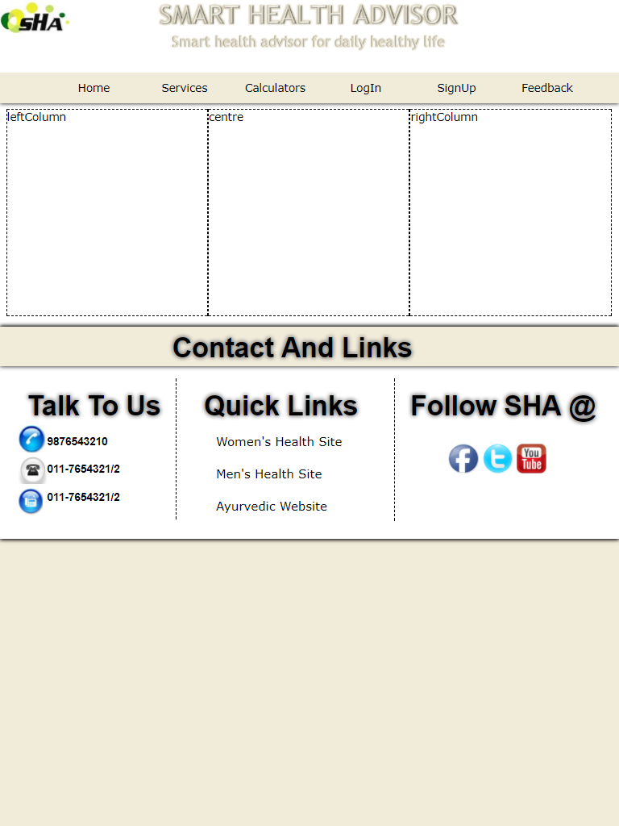

Fig. 4

Basic Layout

**3.2 Home Page**

Home page is the first page that is going to display on opening the link of SHA.

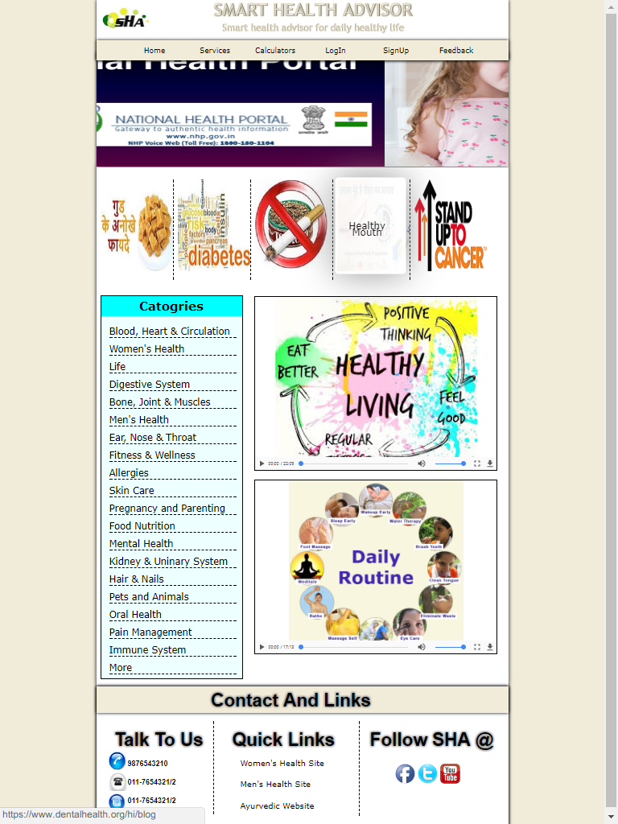

Fig: 5

Home Page

**3.3 Registration Page**

Member Login

Doctor Login

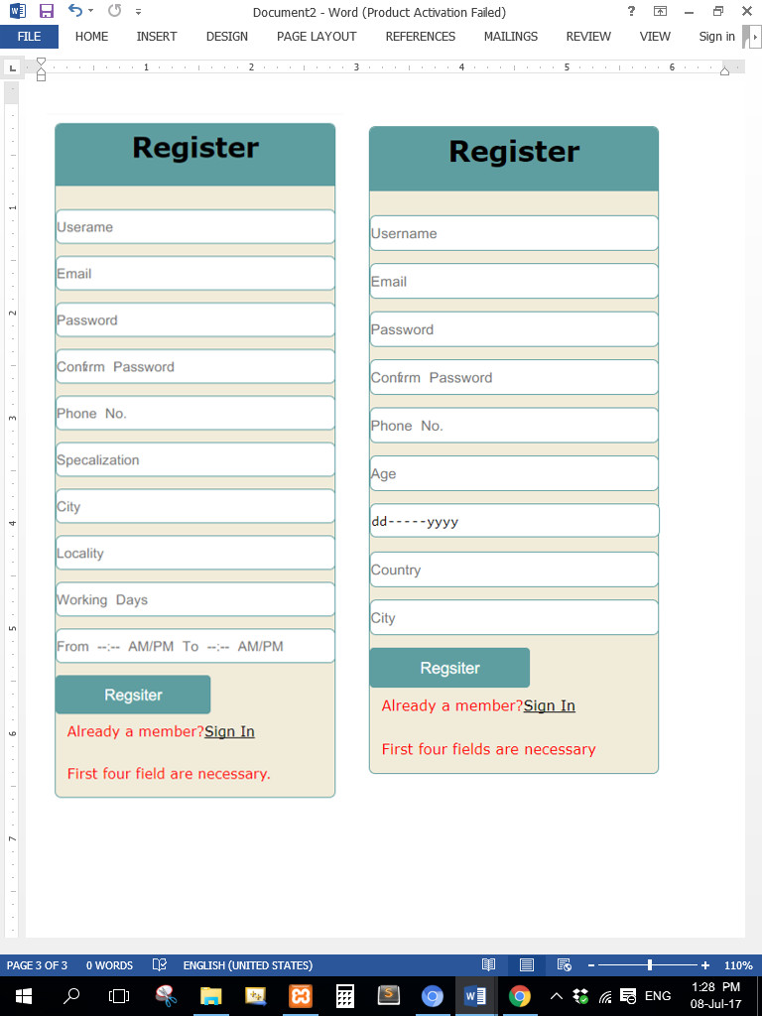

Fig 6

Registration Page

**3.4 Login Page**

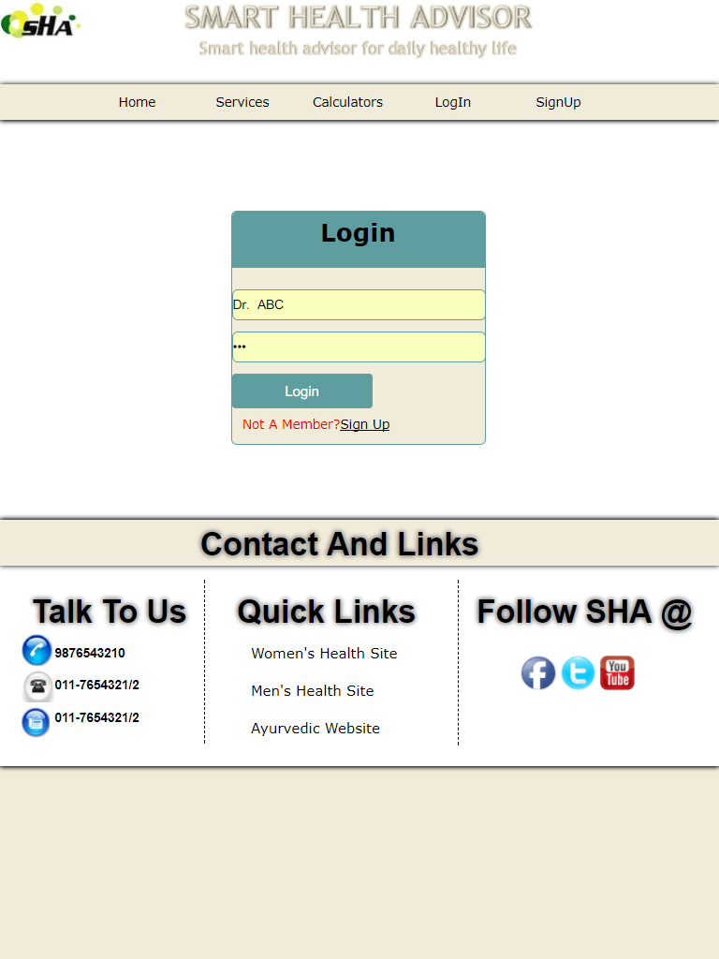The login page for user and doctor have same layout but connected with different tables. Both username and password fields are required and if the input data do not matches with the data stored then error message will be generated.

Fig 7

Login Page

**3.5 User Profile**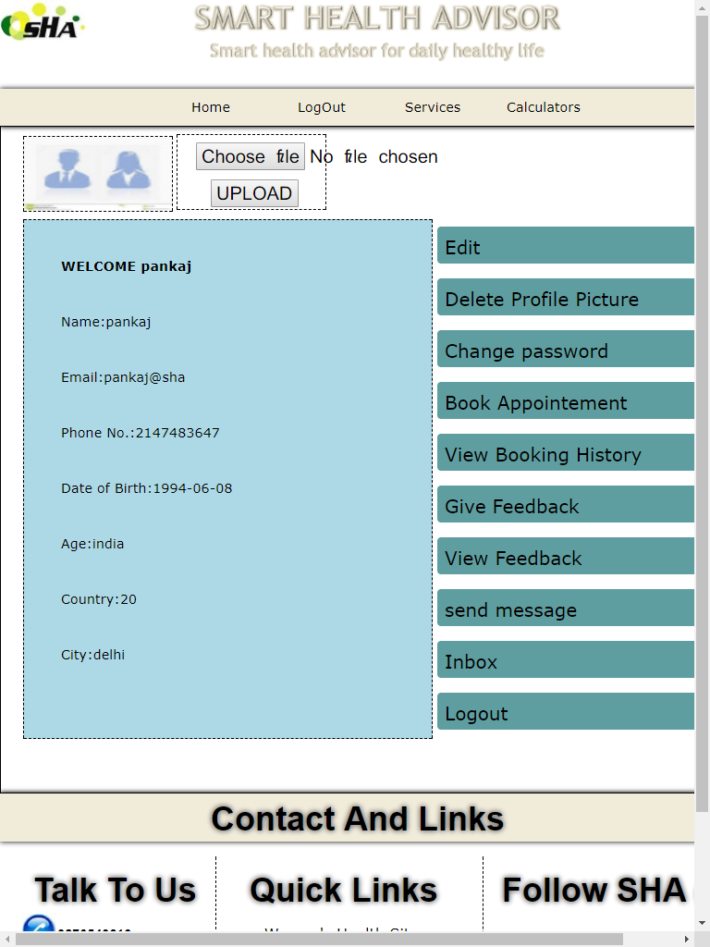

Fig: 8

User Profile

**3.6 Doctor Profile**

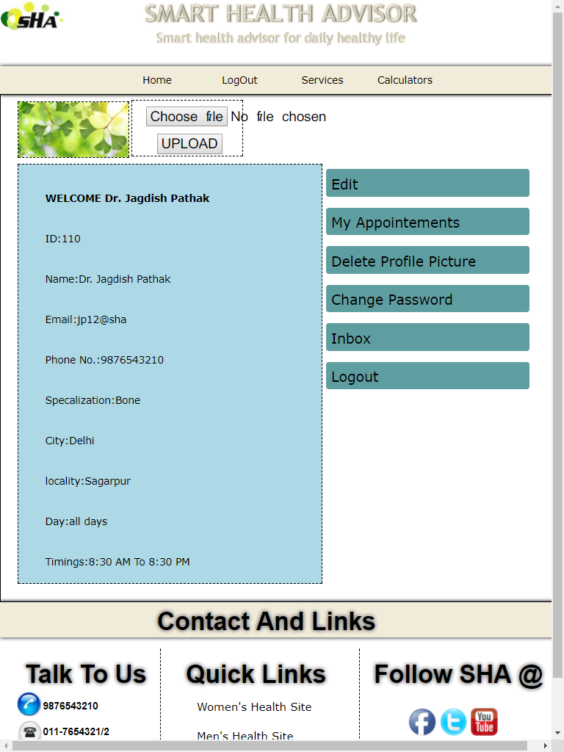

Fig: 9

Doctor Profile

**3.7 BMI Calculator**

**Body Mass Index (BMI)** or Quetelet Index is a value derived from the **mass (weight)** and **height** of an individual. The BMI is defined as the body mass divided by the square of the body height, and is universally expressed in units of **kg/m^2**, resulting from the mass in kilograms and height in meters. The BMI is an attempt to quantify the amount of tissue mass (muscle, fat and bone) in individual, and categorize the person as underweight, normal weight and overweight based on the value of BMI.

The common BMI ranges are:

**UNDERWEIGHT: under 18.5 kg/m^2**

**NORMAL WEIGHT: between 18.5 to 25 kg/m^2 and**

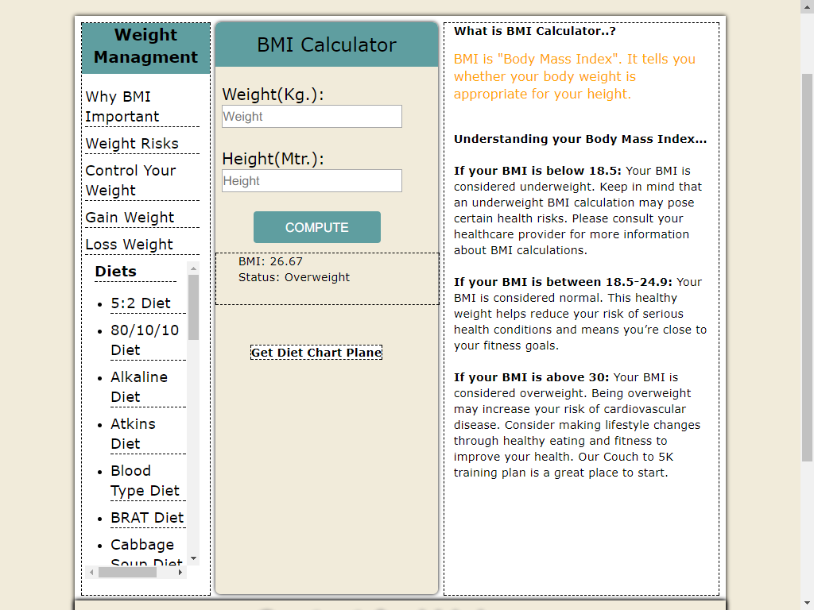**OVERWEIGHT: above 25 kg/m^2.**

Fig: 10

BMI Calculator

**3.7 HEART RATE CALCULATOR**

**Heart rate** is the speed of the heartbeat measured by the number of contractions of the **heart per minute (bpm).** The heart rate can vary according to body’s physical needs, including the need to absorb oxygen and excrete carbon dioxide.

**Normal resting adult human heart rate as ranging from 60-100 bpm.**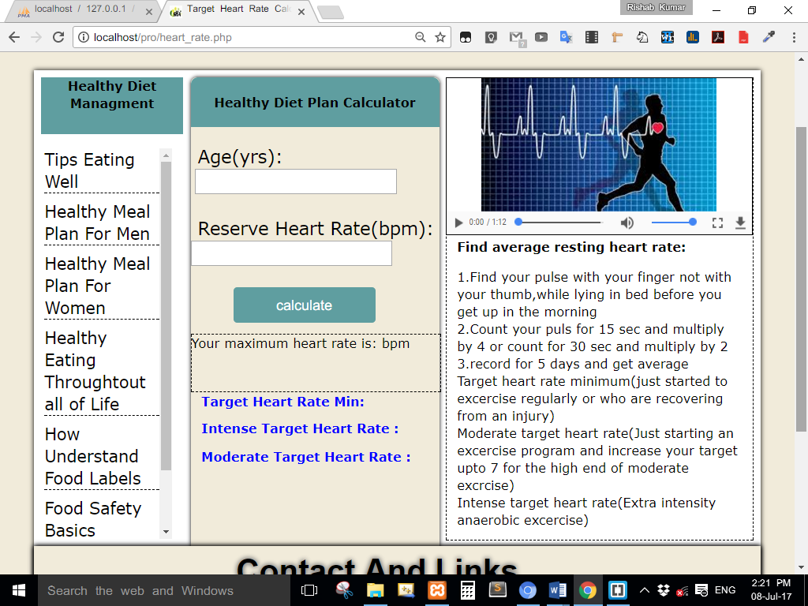

Fig 11

Heart Rate Calculator

**3.8 Body Fat Percentage Calculator**

The **body fat percentage (BFP)** of a human or other living being is the **total mass of fat** divided by the **total body mass;** body fat includes essential body fat and storage body fat.

**The body fat percentage is a measure of fitness level.**

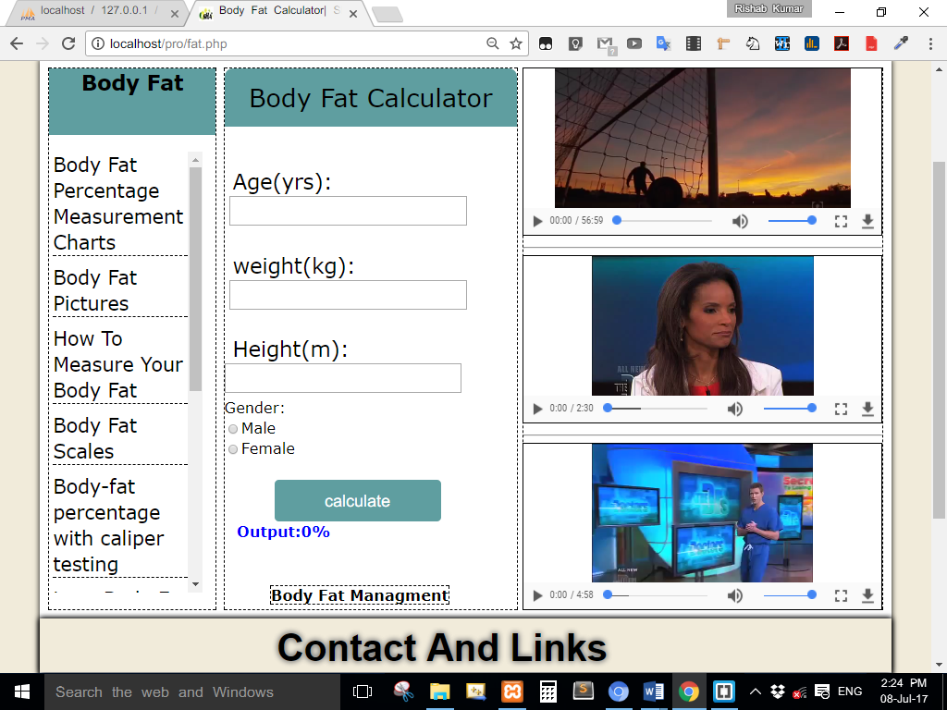

Fig: 12

Body Fat Percentage

**3.9 Appointment**

By this feature user can fix an **appointment** to meet/chat with the doctor. Here, the user sends a request to doctor to discuss problem, if doctor has time and doctor accepts user’s request then user share his/her problem (health related problem) and get a best solution without going any clinics or hospitals.

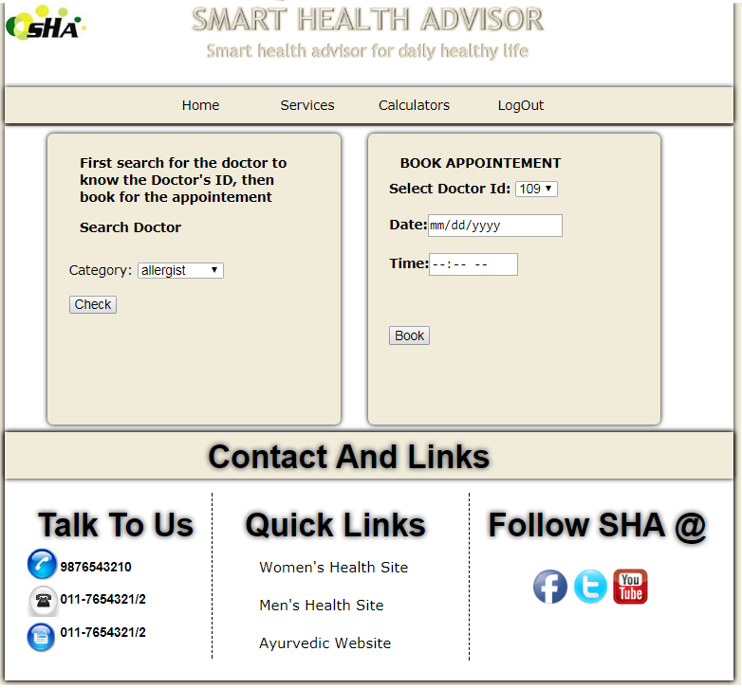

Fig: 13

Appointment

**3.10 Feedback**

There is no common platform which provides facility of giving feedback to a doctor that can be visible to all site visitors.

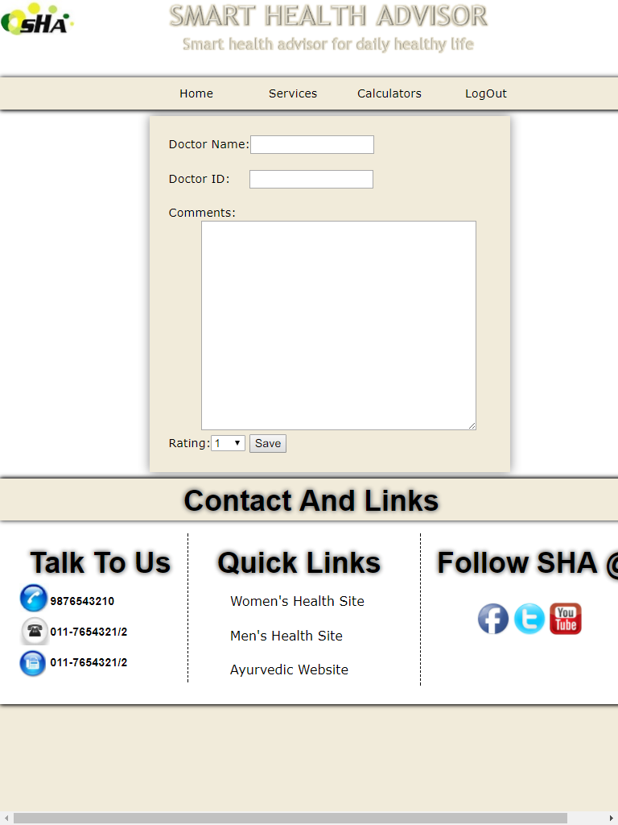

Fig: 14

Feedback

**3.11 Medicine for Different Diseases**

If user know about her/his disease, it’s very easy to get the medicines for that particular disease. Here, the user only need to go to search option for the medicines and get a list of medicines for that diseases. To search the name of suggested medicines users, have to select disease category first and then press “search”, result will be displayed at next page with search again option.

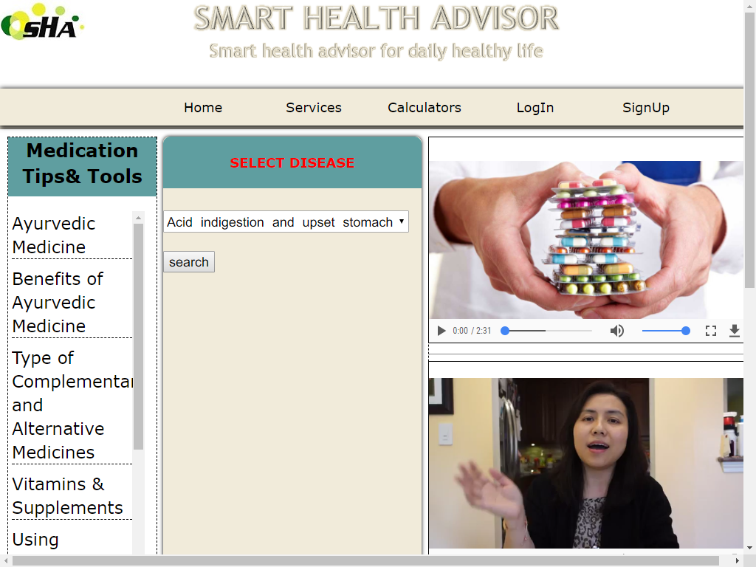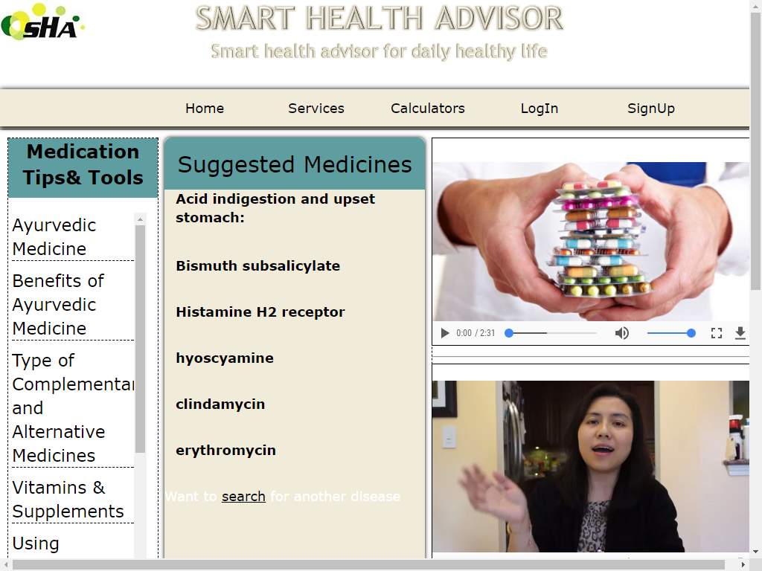

Fig: 15

Search Medicines

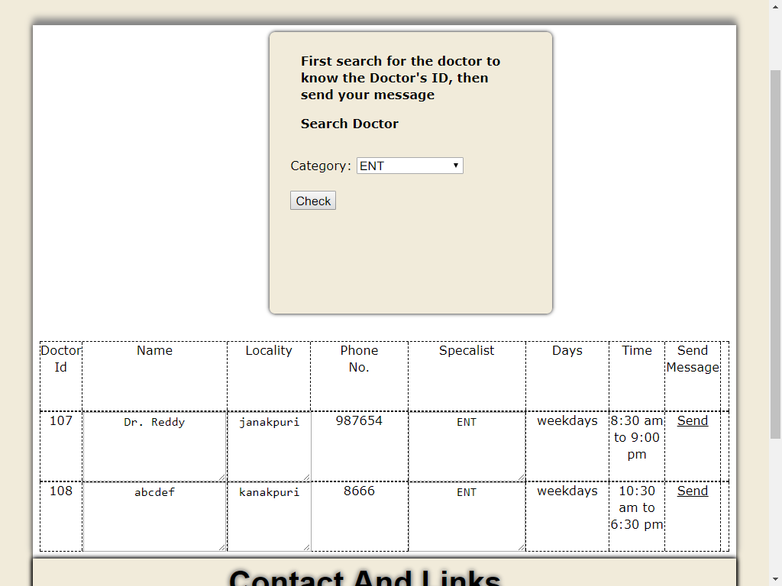**3.12 Send Message**

Fig: 16

Send Message

**3.13 Chat Box**

User and Doctor can chat in real time using end message option.

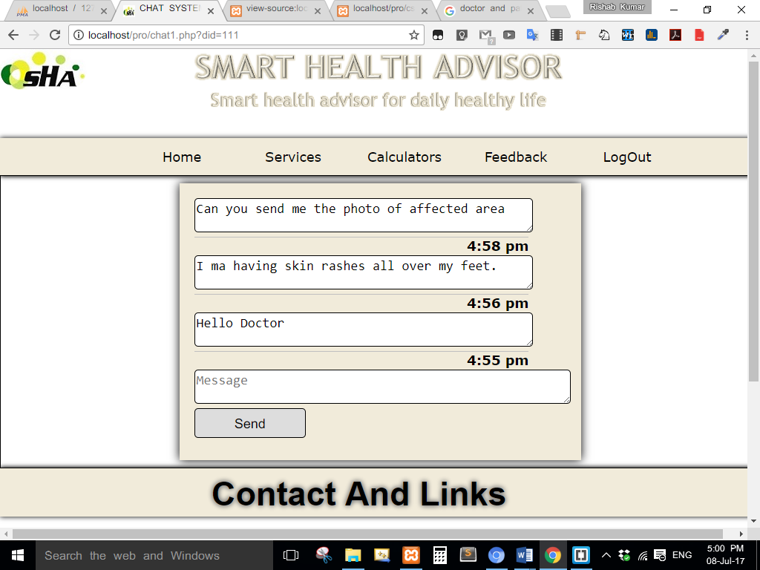

**3.14 Search Emergency Services**

Facility of searching emergency services like hospitals, clinics, pharmacy, etc. is possible with website at ease. Users only have to select country and give the name of location.

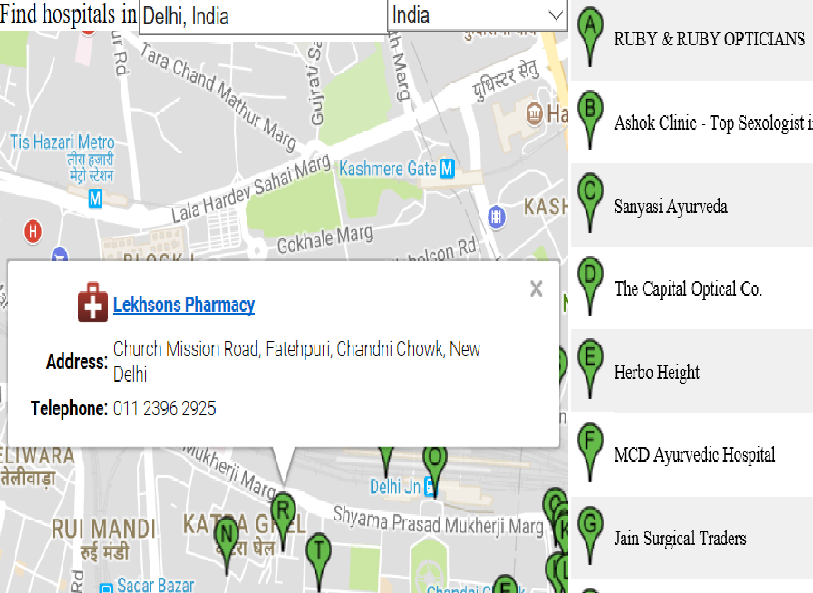

**4. Conclusion**

Website for SMATH HEALTH ADVISOR helps peoples of all region, especially from village areas to find the best environment for good health. To maintain a good health, best of all health parameters, some are provided with website. During treatment there always, some situation arises when patient wants to take second advice and at that time the messaging system will help registered users to get in touch with other experienced doctors. Review and rating system will help users to find best doctors among all, at any location.

**5. Future Scope**

1. More number of calculators are needed to add which are used for monitor and calculate health parameters.
2. Site Map and FAQs are needed to add.
3. Latest news feed from different health related website and magazines and news reader for all supported language.
4. Single window system for comparing health insurance products provided by different companies.
5. Health related myths and their truths.
6. More Ayurveda and Yoga related articles.
7. Website availability in different language i.e. Hindi, Bangla, Marathi, etc.
8. **Bibliography**
9. Research-Based Web Design & Usability Guidelines by Michael O. Leavitt Secretary of Health and Human Services Ben Shneiderman Professor of Computer Science, University of Maryland
10. The design and implementation of an e-commerce site for online book sales by Swapna Kodali, Project Report Submitted to the faculty of the University Graduate School in partial fulfillment of the requirements for the degree Master of Science in the Department of Computer and Information Sciences Indiana University South Bend May 2007.
11. <https://www.w3schools.com/html/default.asp> HTML Tutorials
12. b<https://www.w3schools.com/css/default.asp> CSS Tutorials
13. <https://www.w3schools.com/php/default.asp> PHP Tutorials
14. <https://www.w3schools.com/js/default.asp> JACASCRIPT Tutorials
15. [www.youtube.com/](http://www.youtube.com/)[ProgrammingKnowledge](https://www.youtube.com/channel/UCs6nmQViDpUw0nuIx9c_WvA)/PHP Tutorial for Beginners
16. <http://nevonprojects.com/advance-artificial-intelligence-dietician/>
17. <http://www.onlineustaad.com/chat-system-in-php-urdu/>
18. <https://www.nhp.gov.in/>
19. <http://www.healthycalculators.com/blood-donation.php>

**APPENDIX**

**7.1 SOURCE CODES**

**7.1.1 Databse Connection | db.php**

<?php

$servername = "localhost";

$username = "root";

$password = "";

$db_name = "registration";

$db = new mysqli( $servername, $username, $password, $db_name );

functionformateDate($date)

{return date('g:i a', strtotime($date));}

?>

**7.1.2 Head Codes** | Head.php

<head>

<meta charset="utf-8">

<link rel="stylesheet" href="css/BasicStyle.css" type="text/css">

<meta name="viewport" content="width=device-width, initial-scale=1.0">

<meta name="keyword" content="SMART HEALTH ADVISER,ASET MINOR PROJECT,CSE MINOR PROJECT">

<meta name="description" content="web Site Development Project for SMART HEALTH ADVISOR">

<meta http-equiv="refresh" content="60">

<meta http-equiv="X-UA-Compatible" content="IE=edge">

<link rel="shortcut icon" href="img/fevicon.jpg">

</head>

**7.1.3 Footer Codes** | Footer.php

<div id="footer">

<div id="footer_plate" >

<h5>Contact And Links</h5>

</div>

<div id="callus" style="float:left; margin:20px;">

<h5 style=" ">Talk To Us</h5>

<div style="float:left;">

<div id="mobile" style="">

<imgsrc="img/mobile.jpg" height="45px" >

</div>

<div id="telephone" style=" ">

<imgsrc="img/telephone.jpg" height="45px" >

</div>

<div id="fax" style=" ">

<imgsrc="img/fax.jpg" height="45px" >

</div></div>

<div style=" padding-top:10px;">

<h4 style=" ">9876543210</h4>

</div>

<div style=" padding-top:10px;">

<h4 style="">011-7654321/2</h4>

</div>

<div style=" padding-top:10px;">

<h4 style=" ">011-7654321/2</h4>

</div></div>

<div id="shortintro" style=" ">

<h5>Quick Links</h5>

<a id="blog" href="http://www.healthywomen.org" target="_blank">Women's Health Site</a>

<a id="blog" href="http://www.menshealth.com/"target="_blank">Men's Health Site</a>

<a id="blog" href="http://www.onlymyhealth.com/hindi-ayurvedic-treatment-1296115161.html" target="_blank">Ayurvedic Website</a></div>

<div id="followus" style="">

<h5 style=" " >Follow SHA @</h5>

<div id="logos"><a href="facebook/Smart Health Advisor">

<imgsrc="img/fb.jpg" alt="FB logo" height="50px" ></a>

<a href="twitte/#SHA">

<imgsrc="img/twitter.jpg" alt="twitter logo" height="50px" ></a>

<a href="yt/Smart Health Advise">

<imgsrc="img/youtube.jpg" alt="youtube" height="50px" ></a>

</div></div></div>

**7.1.4 Basic Layout codes** | Basiclayout.php

<!doctype html>

<html>

<?php include 'head.php';

echo "<title>Basic Layout | SMART HEALTH ADVISOR</title>

<link rel='stylesheet' href='css/BasicLayout.css' type='text/css'>";

?>

<body>

<div id="container"><!--Container Starts-->

<div id="header">

<imgsrc="img/icon.jpg" alt="SHA logo" id="logo5">

<imgsrc="img/SHA_Plate2.PNG" alt="SHA_Plate" id="SHA">

<div id="navigation">

<ul id="" >

<li><a href="Home.php">Home</a></li>

<li><p>Services</p><ul>

<li><a href="project3.html">Search Emergency Services</a></li>

<li><a href="medicine.php">Search Medicines</a></li>

</ul></li>

<li><p>Calculators</p>

<ul>

<li><a href="Bmi.php">BMI Calculator</a></li>

<li><a href="heart_rate.php">Target Heart Rate</a></li>

<li><a href="fat.php">Body Fat Calculator</a></li>

<li><a href="http://www.healthycalculators.com/blood-donation.php" target=_blank>Blood Donation Calculator</a></li>

<li><a href="http://www.healthycalculators.com/">Others</a></li>

</ul></li>

<li><p>LogIn</p>

<ul>

<li><a href="login.php">Member LogIn</a></li>

<li><a href="dlogin.php">Doctor Login</a></li>

</ul>

<li><p>SignUp</p>

<ul>

<li><a href="register.php">Member SignUp</a></li>

<li><a href="dregister.php">Doctor SignUp</a></li>

</ul></li>

<li><a href="viewfeedback.php">Feedback</a></li>

</ul></div></div>

<!--====== header ends here====-->

<div id="middle">

<div id="leftColumn">

leftColumn

</div>

<div id="centre">

Centre</div>

<div id="rightColumn">

rightColumn</div></div>

<?php include 'footer.php'; ?>

</div><!--Container Ends--></body></html>

**7.1.5 BMI Codes | Bmi.php**

<?php include('server.php'); ?>

<?php

function calculate_bmi($height,$weight)

{

$height = $height * $height;

$BMI = $weight / $height;

$BMI = round($BMI,2);

return $BMI;

}

function bmi_result($BMI)

{

$result = '';

if($BMI < 18.5){$result = 'Underweight';}

if(18.5 <= $BMI && $BMI < 25){$result = 'Normal';}

if(25 <= $BMI){$result = 'Overweight';}

return $result;

}?>

<div id="bmi_top"> BMI Calculator </div>

<form method="post" class="BMI" action="bmi.php">

<div class="input-group" >

<label>Weight(Kg.):</label>

<input style="margin-left:10px;" type="text" name="weight" placeholder="Weight" id="weight" value="" required></div>

<div class="input-group">

<label>Height(Mtr.):</label>

<input style="margin-left:10px; type="text" name="height" id="height" placeholder="Height" value="" required></div>

<div class="input-group"><button type="submit" name="COMPUTE" class="btn" value="COMPUTE">COMPUTE</button></div>

<div id="result">

<?php

if (isset($_POST['height']))

{

$height = $_POST['height'];

$weight = $_POST['weight'];

$BMI = calculate_bmi($height,$weight);

$status = bmi_result($BMI);

echo "<div align='left' style='margin-left:35px;'>";

echo "BMI: ".$BMI;

echo "<br>";

echo "Status: ".$status;

echo "</div>";

}

?>

</div>

<a id="diet_button" href="dietchart.html" style=""><strong>Get Diet Chart Plane</strong></a><br>

</form></div>

</div><!--================ centre ends here===============-->

</div><!--================ Middle ends here===============-->

<?php include 'footer.php'; ?></div><!--Container Ends-->

</body></html>

**7.1.6 BOOK Appointment | bookappointment.php**

<?php

session_start();

$var=$_SESSION['username'];

mysql_connect("localhost","root","");

mysql_select_db("registration");

$search= mysql_real_escape_string($_POST['date']);

$time= mysql_real_escape_string($_POST['time']);

$category= mysql_real_escape_string($_POST['category']);

if(isset($_POST['check']))

{

$time= mysql_real_escape_string($_POST['time']);

$category= mysql_real_escape_string($_POST['category']);

$fields = array( 'category',);

$error = false; //No errors yet

foreach($fields AS $fieldname) { //Loop trough each field

if(!isset($_POST[$fieldname]) || empty($_POST[$fieldname])) {

echo 'Field '.$fieldname.' misses!<br />';

echo "<script type='text/javascript'>alert('cannot search');</script>";

$error = true; //Yup there are errors

}}

if(!$error)

{

$searchterm=mysql_real_escape_string(trim($_POST['category']));

$find=mysql_query("SELECT * FROM doctor WHERE category LIKE'$searchterm' ");

while($row=mysql_fetch_assoc($find))

{

$diseases=$row['did'];

$name1=$row['dname'];

$name2=$row['dadress'];

$name3=$row['dmobile'];

$name4=$row['category'];

$name5=$row['day'];

$name6=$row['time'];

//$name7=$row['Rating'];

echo "<table cellspacing='50' cellpading='400' width='700' display:block>

<tr>

<th><u>Doctor Id</u></th>

<th><u>Name</u></th>

<th><u>Adress</u></th>

<th><u>Phone no.</u></th>

<th><u>Specalist</u></th>

<th><u>Days</u></th>

<th><u>Time</u></th>

</tr>

<tr>

<td>$diseases</td>

<td>$name1</td>

<td>$name2</td>

<td>$name3</td>

<td>$name4</td>

<td>$name5</td>

<td>$name6</td>

</tr>

</table>";

}}}

if(isset($_POST['submit3']))

{$search= mysql_real_escape_string($_POST['date']);

$time= mysql_real_escape_string($_POST['time']);

$category= mysql_real_escape_string($_POST['category']);

$id= mysql_real_escape_string($_POST['id']);

$fields = array('date', 'category', 'time');

$error = false; //No errors yet

foreach($fields AS $fieldname) { //Loop trough each field

if(!isset($_POST[$fieldname]) || empty($_POST[$fieldname])) {

echo 'Field '.$fieldname.' misses!<br />';

echo "<script type='text/javascript'>alert('cannot booked');</script>";

$error = true; //Yup there are errors

}}

if(!$error)

{$con=mysqli_connect("localhost","root","","registration");

//mysql_select_db("registration");

$query="INSERT INTO bookinghistory (did,uname,date,time,category) VALUES ('$id' ,'$var', '$search', '$time', '$category')";

$res=mysqli_query($con,$query);

if($res)

{ header('location:profile.php');}

else{

echo "<h1>not able to book</h1>";

echo "<script type='text/javascript'>alert(' can't Booked');</script>";

} }}?>

**7.1.8 Feedback**

**Feedback form | feedback.php**

<form action="feedback1.php" method="post">

Doctor Name:<input id="name" type="text" name="dname" value="" ><br><br>

Doctor ID:<input id="id" type="text" name="did" value="" ><br><br>

Comments:<br><textarea id="review" name="comments" rows="15" cols="40"></textarea><br>

Rating:<select id="rate" name="rating" required>

<option value="1">1</option>

<option value="1">1.5</option>

<option value="2">2</option>

<option value="2">2.5</option>

<option value="3">3</option>

<option value="3">3.5</option>

<option value="4">4</option>

<option value="4">4.5</option>

<option value="5">5</option>

</select>

<input type="submit" name="submit" value="Save">

</form>

**Writing Feedback into Database | feedback1.php**

<!doctype html>

<html><head><title>feedback</title>

<meta charset="utf-8">

</head><body>

<?php session_start();

$username=$_SESSION['username'];

mysql_connect("localhost","root","");

mysql_select_db("registration");

$doctorname=$_POST['dname'];

$did=$_POST['did'];

$search=$_POST['comments'];

$rating=$_POST['rating'];

$find=mysql_query("INSERT INTO feedback (Name,dname,did,comments,rating)VALUES('$username','$doctorname','$did','$search','$rating')");

if($find)

{ echo "Success Fully Updated";

header("refresh:2;url=profile.php")}

?></body></html>